

**ABHINAV VIJAYAKUMAR**

**19BCE1311**

**CSE3506 – ESSENTIALS OF DATA ANALYTICS LAB-7**

**DR. LAKSHMI PATHI JAKKAMPUTI (L21 + L22)**

**--------------------------------------------------------------------------------------------**

**Tasks for Week-7: Partitioning Based Clustering**

**Aim**: To understand the following operations/functions on ‘iris’ data and perform similar operations on ‘USArrests’ dataset based on given instructions.

**Algorithm:**

**1.** Removing all the values from the global environment

**2.** Set the working directory to the dataset where we store by using setwd().

**3.** To see the dataset use view() function.

**4.** By using scale function. We scale the data and store it in another variable.

**5.** Using kmeans function we find the kmeans clustering with 2 center at first it can be of any centers and store the result in fit.

**6.** By using fit$cluster we can find the cluster values.

**7.** By using fit$size we can find the size of each cluster.

**8.** By using fit$withnss we can find with in cluster sum of squares for each cluster.

**9.** By using fit$tot.withnss we can find with in cluster sum of squares with respective to all clusters.

**10.** Create the no of iterations we need to find the perfect cluster and size of wcss and the nclust list.

**11.** To find the best no of center from 1 to 15 we create a for loop.

**1.** find the kmeans cluster with each center value in for loop

**2.** put to the total with in cluster sum of squares for each iteration in wcss

**3.** put the size of cluster in nclust.

**12.** Plot the graph between the no of center and the wcss values for each center. the place where we find the bend that is our no of cluster should be taken.

**13.** In other way we can use factoextra library.

**14.** Using fviz_nbclust function we can find the graph.

**15.** Using fviz_cluster function we can find the clusters

**16.** Call cluster library

**17.** We use pam function to find the k medoid clusters and store the values in fitm.

**18.** By using the fitm$medoid we can find no of medoid.

**19.** Using fviz_cluster function we can find the medoids.

**Result:**

***For iris.csv***

**K-means centers:**

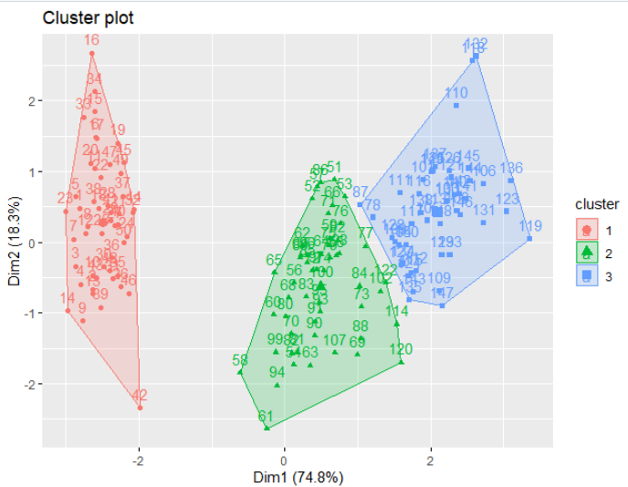

**K-medoid centers:**

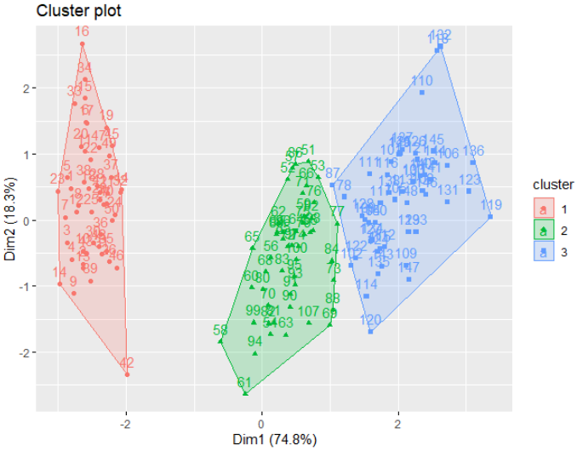

***For USArrests.csv***

**K-means centers:**

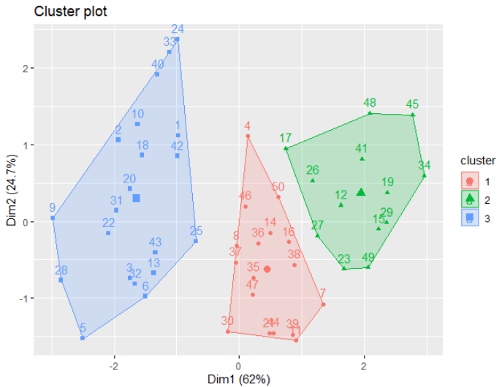

**K-medoid centers:**

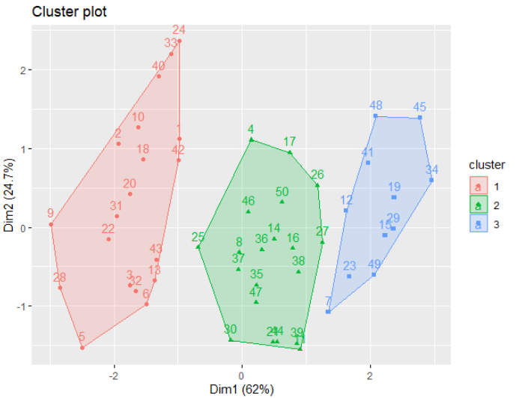

**Statistics:**

***For iris.csv***

* **K-means centers**

|  |  |  |  |  |
| --- | --- | --- | --- | --- |
| X | Sepal.Length | Sepal.Width | Petal.Length | Petal.Width |
| -1.15087068 | **-1.01119138** | **0.85041372** | **-1.3006301** | **-1.2507035** |
| 0.07534946 | **0.03881135** | **-0.73324663** | **0.3059615** | **0.2137533** |
| 1.13936197 | **1.03196952** | **-0.07784286** | **1.0386287** | **1.0894947** |

* **K-medoid centers**

|  |  |  |  |  |
| --- | --- | --- | --- | --- |
| X | Sepal.Length | Sepal.Width | Petal.Length | Petal.Width |
| -1.07030973 | **-0.7769106** | **0.7861738** | **-1.3357516** | **-1.3110521** |
| -0.08056095 | **0.3099591** | **-0.5903951** | **0.1370873** | **0.1320673** |
| 0.95522266 | **0.7930124** | **-0.1315388** | **0.9868021** | **0.7880307** |

***For USArrests.csv***

* **K-means centers**

|  |  |  |  |
| --- | --- | --- | --- |
| Murder | Assault | UrbanPop | Rape |
| -0.4469795 | **-0.3465138** | **0.4788049** | **-0.2571398** |
| -0.9615407 | **-1.1066010** | **-0.9301069** | **-0.9667633** |
| 1.0049340 | **1.0138274** | **0.1975853** | **0.8469650** |

* **K-medoid centers**

|  |  |  |  |
| --- | --- | --- | --- |
| Murder | Assault | UrbanPop | Rape |
| 0.8292944 | **1.3708088** | **0.3081225** | **1.1603196** |
| -0.2727580 | **-0.2371077** | **0.1699510** | **-0.1315342** |
| -1.2829727 | **-1.3770485** | **-0.5899924** | **-1.0603878** |

**Program:**

***For iris.csv***

rm(list=ls())

setwd("C:/Users/Abhinav Vijayakumar/Desktop/VIT Academics/Sem 6/EDA/LAB/LAB 7")

data1<-read.csv("iris.csv")

View(data1)

df<-scale(data1)

fit<-kmeans(df,centers=2)

fit$cluster

fit$size

fit$withinss

fit$tot.withinss

Kmax<-15

wcss<-rep(NA,Kmax)

nClust<- list()

for(i in 1:Kmax){

fit<-kmeans(df,i)

wcss[i]<-fit$tot.withinss

nClust[[i]]<-fit$size

}

plot(1:Kmax,wcss,type="b",pch=19)

fit<-kmeans(df,centers=3)

fit$cluster

fit$size

fit$center

library(factoextra)

fviz_nbclust(df, kmeans, method = "wss")

fviz_cluster(fit, data1)

library(cluster)

fitm <- pam(df, 3, metric = "manhattan")

fitm

fitm$medoids

fviz_cluster(fitm, data1)

***For USArrests.csv***

rm(list=ls())

setwd("C:/Users/Abhinav Vijayakumar/Desktop/VIT Academics/Sem 6/EDA/LAB/LAB 7")

data2<-read.csv("USArrests.csv")

view(data2)

data2<-data2[,-1]

df1<-scale(data2)

fit1<-kmeans(df1,centers=2)

fit1$cluster

fit1$size

fit1$withinss

fit1$tot.withinss

Kmax1<-15

wcss1<-rep(NA,Kmax1)

nClust1<- list()

for(i in 1:Kmax1){

fit1<-kmeans(df1,i)

wcss1[i]<-fit1$tot.withinss

nClust1[[i]]<-fit1$size

}

plot(1:Kmax1,wcss1,type="b",pch=19)

fit1<-kmeans(df1,centers=3)

fit1$cluster

fit1$size

fit1$center

library(factoextra)

fviz_nbclust(df1, kmeans, method = "wss")

fviz_cluster(fit1, data2)

library(cluster)

fitm1 <- pam(df1, 3, metric = "manhattan")

fitm1

fitm1$medoids

fviz_cluster(fitm1, data2)